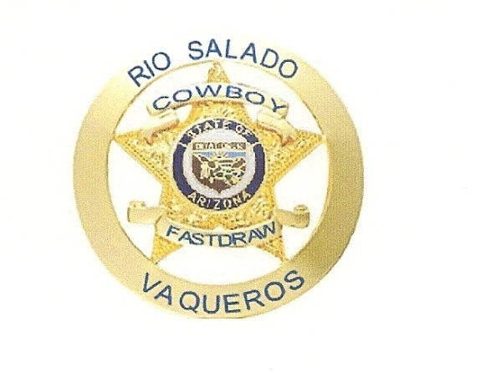
RIO SALADO VAQUEROS
Membership Form
Name Alias
Address City Zip

Phone # Cell #
Email
CFDA # Member of NRA Yes Νο
(Must be a member of CFDA) Member of Rio Salado Sportsman’s Club Yes Νο
Received copy of our By Laws Yes

Annual Dues $24.00 per year ($2.00 per month, expires April 30) $
Badge (optional) $40.00 for badge plus shipping (estimate) Yes Νο
Pay $40.00 now and when received pay the extra cost
(approximate 6-8 weeks)

Signature of Applicant Date
Signature of Parent Date

Do Not Write Below This Line
Date Received Payment Type Membership #

